Time series & category charts using Python
Project Objectives & Insights
1. Sales Trends & Periodicity (Monthly & Quarterly)
- Objective: Plot sales over time using line charts with both monthly and quarterly aggregations.
- Insight: * Monthly: Revealed sharp peaks every November and December, indicating a strong holiday impact.
  - Quarterly: By aggregating data into quarters, I identified a consistent Q4 surge across all years, which helps the business plan for inventory and staffing levels months in advance.
- Visual Choice: Line Charts were used for both views to effectively visualize growth trends and contrast short-term fluctuations (monthly) with long-term cycles (quarterly).
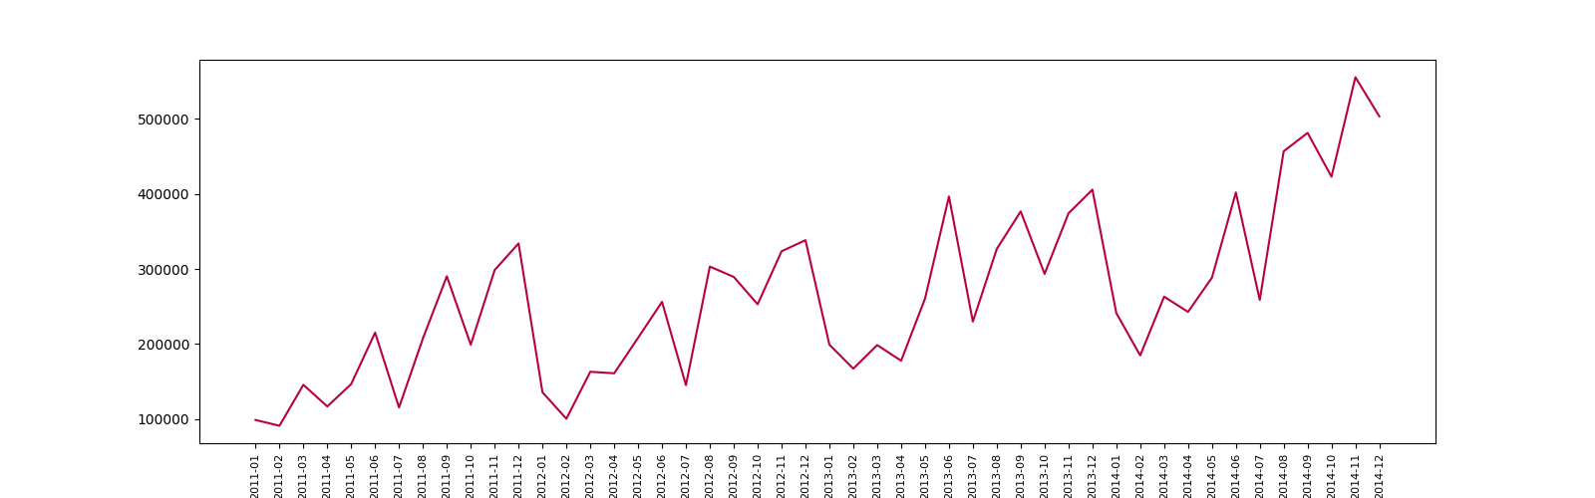
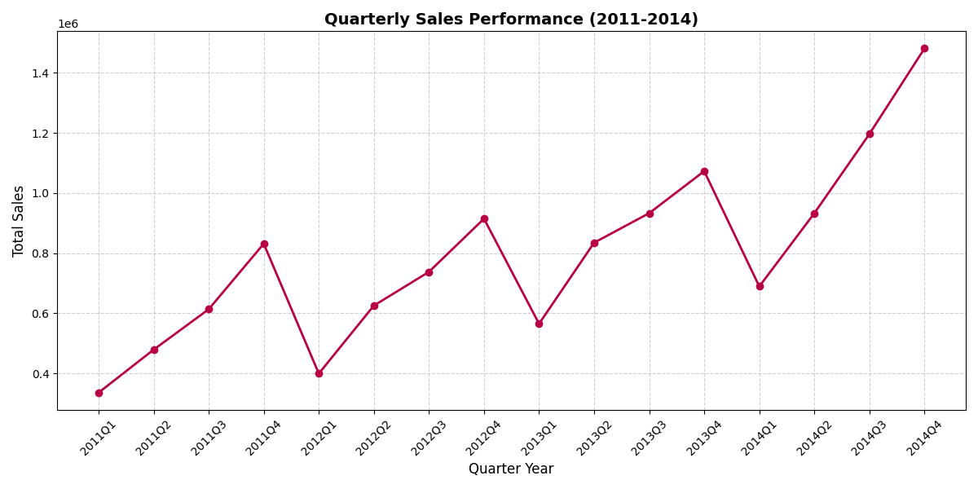
2.Category Performance & Market Share
- Objective: Use bar charts to compare categories and pie charts for market share.
- Insight: Technology is the dominant category, holding a 37.5% share of total sales.
- Visual Choice: * Bar Charts: Provided a clear baseline for comparing sales volume across Furniture, Office Supplies, and Technology.
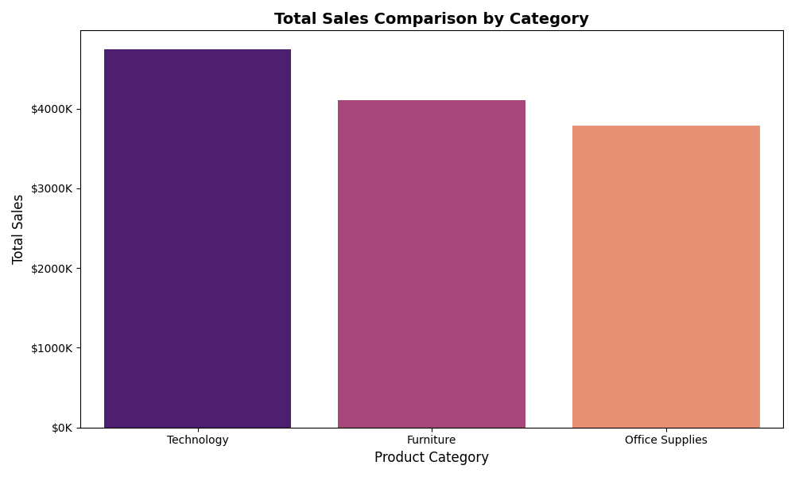
  - Pie Charts: Immediately identified which "slice" of the business generates the most revenue.

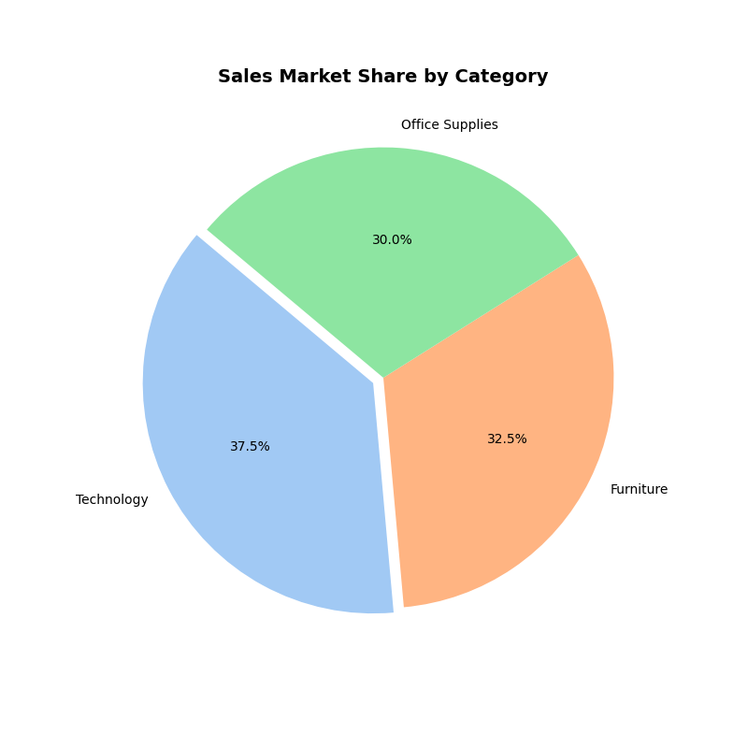

3. Product & Profitability Rankings
- Objective: Identify the Top 10 products by sales, the most selling products, and the most profitable categories.
- Findings: * Revenue Leaders: Apple Smart Phones and Cisco Smart Phones are the top revenue generators.
  - Volume Leaders: Staples is the most frequently sold product by quantity.
  - Profitability: Technology is the most profitable category ($663,778), with Copiers and Phones leading the sub-categories.
4. Logistics & Shipping Preferences
- Objective: Identify the most preferred Ship Mode.
- Insight: Standard Class is the most preferred method by far, used for over 30,000 orders.
- Business Impact: This suggests that the customer base is highly price-sensitive and willing to accept longer delivery times for lower costs.
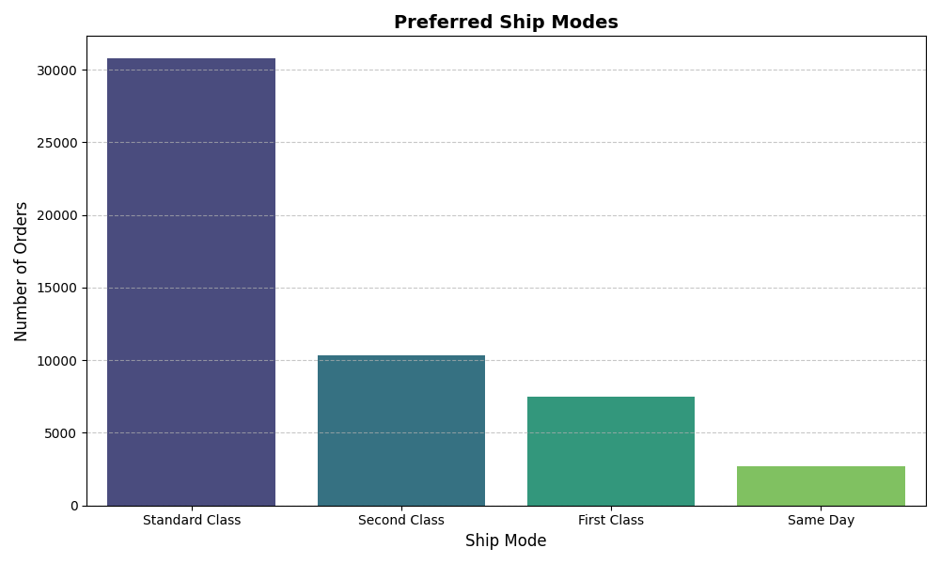

Technologies Used
- Python: Primary analysis language.
- Pandas: For data cleaning and multi-level aggregations (Monthly/Quarterly).
- Matplotlib & Seaborn: For creating professional-grade visualizations.
- Jupyter Notebook: For documenting the step-by-step analysis.

